User Manual
How to use SpecterX Workspaces



With This Manual You Will Learn
Requesting a File Securely using SpecterX Web Platform
Logging in to the SpecterX web platform 4
Request a file 4
Uploading Files Securely with SpecterX Workspaces
Authentication for recipients using One-Time-Password 6
Upload files 7
Accessing Files Securely with SpecterX Workspaces 9

Requesting a File Securely using SpecterX Web Platform

Logging in to the SpecterX web platform
- Log in to your tenant address https://XXX.specterx.com
- Sign in with your preferred authentication method. If your organization has Microsoft or Google identities, it is recommended to choose the matching button.
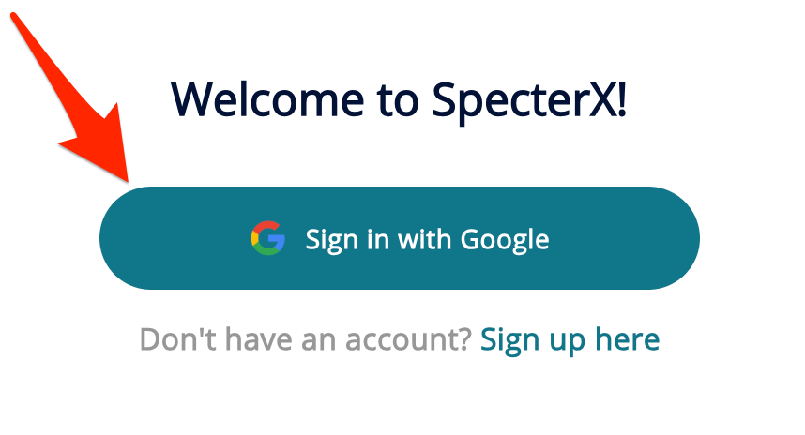

Request a file
- Click the ‘Request files’ button on the left side of the screen
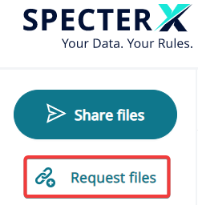

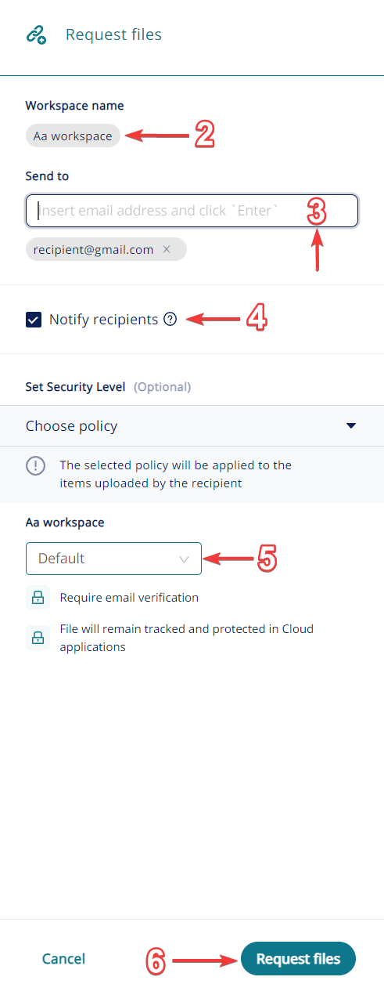
- Search for an existing workspace by entering the workspace name or click ‘Create new workspace’ to create a new one.
- Enter the recipient email address
(You can enter multiple addresses)
- Choose if the recipient will get a notification email
- Choose a security policy from the drop down menu
- Click ‘Request files’

Uploading Files Securely with SpecterX Workspaces

Authentication
Recipients will be required to authenticate using a One-Time-Passowrd (OTP) which will be sent to their email address in order to upload files to the Workspace:
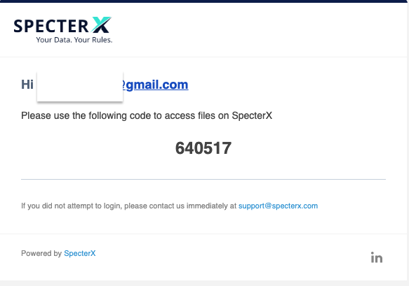

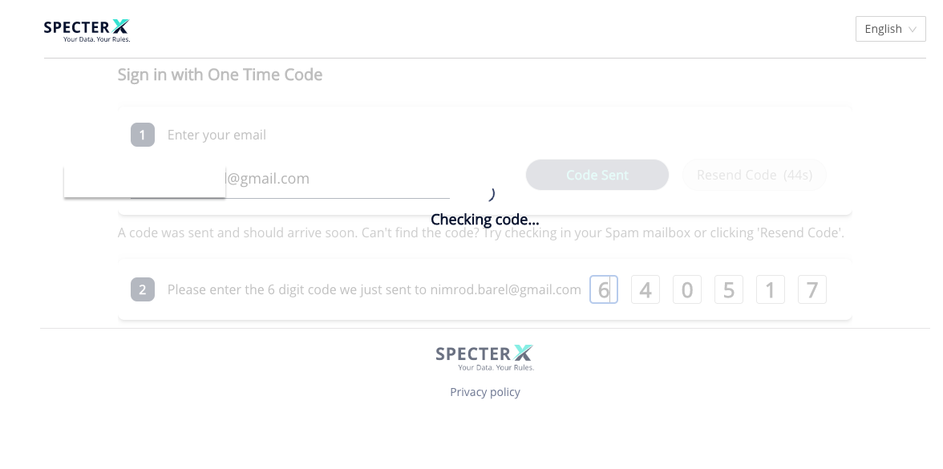

Uploading files
Following authentication, recipients will be able to upload their files securely to the workspace.
- Click on ‘Choose a file or drag it here’ or drag the files.
- When upload has been completed, click the ‘Share Securely’ button

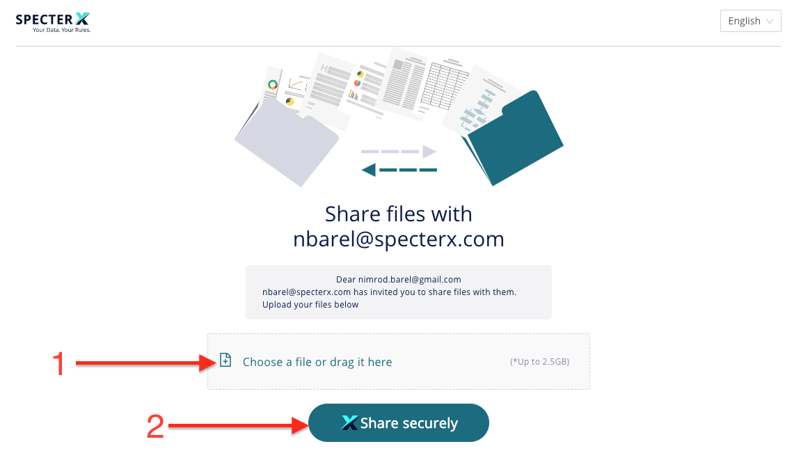

*The upload status of each file can be viewed in the bottom-right widget:

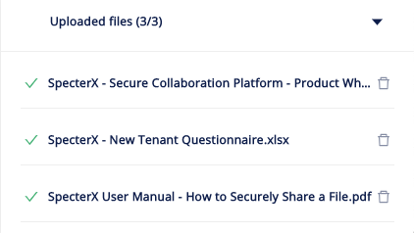

After clicking the ‘Share Securely’ button you will get a confirmation message:

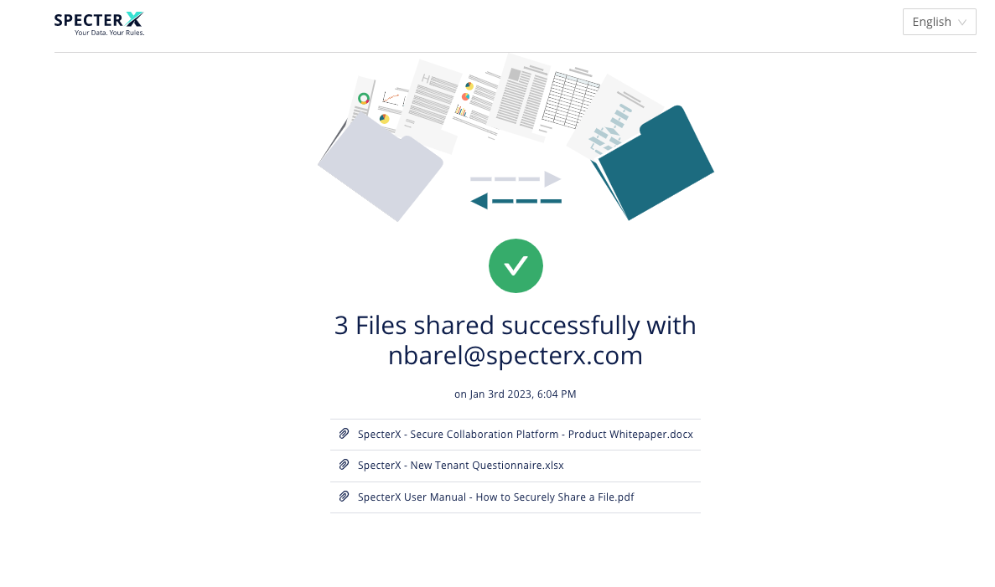

Accessing Files Securely with SpecterX Workspaces
As the ‘Data Owner’, access the SpecterX tenant and choose the desired workspace under the ‘My files’ section:

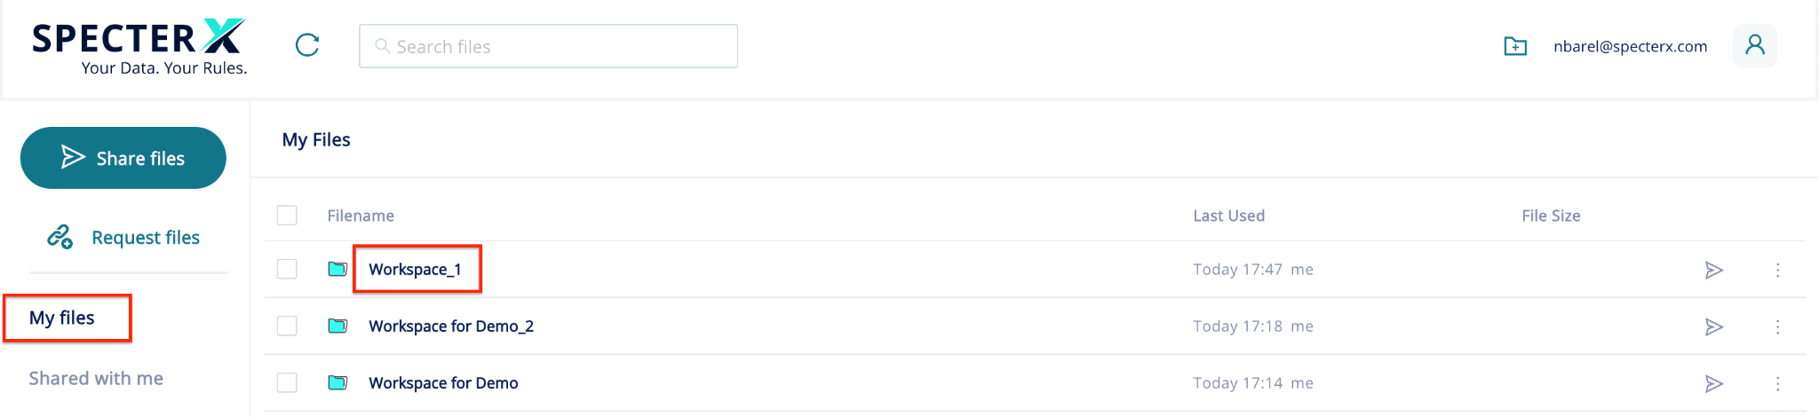

Open/Share/Download or choose another option for the selected files:
